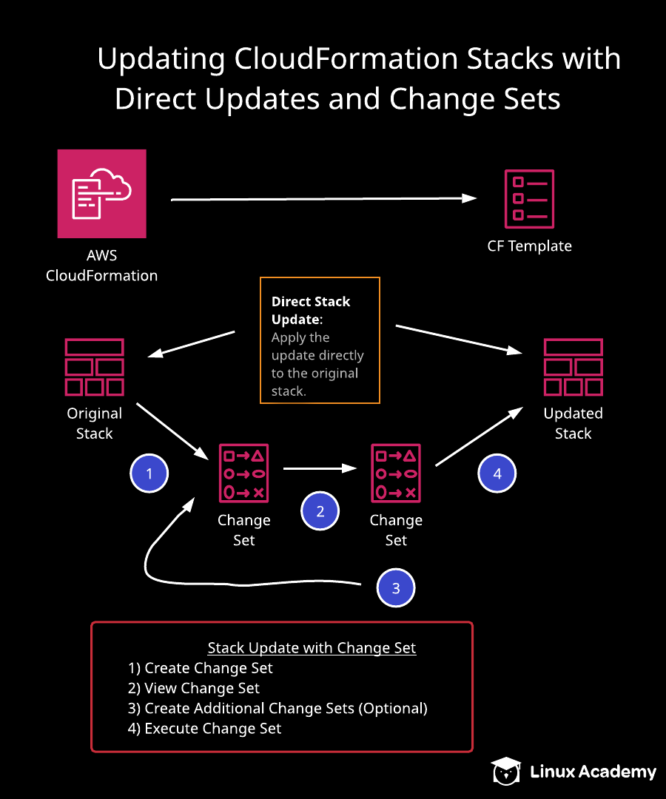
Additional Information and Resources
Please log in to the AWS environment using the credentials provided. Make sure you are using us-east-1 (N. Virginia) as the selected region.
The lab uses two CloudFormation templates, which you can download at the lab GitHub repository.
Learning Objectives
Deploy a LAMP Stack Using an AWS CloudFormation Template

- From the CloudFormation console, click Create stack.
- Upload the LAMP stack template provided with the lab, and create the stack.

Update the LAMP Stack

- From the CloudFormation console, click Update stack.
- Perform a direct update in which you change the instance type from t2.micro to t2.small.
- Complete the update.

Updating CloudFormation Stacks with Direct Updates and Change Sets

Introduction
In this hands-on lab, we will walk through proper ways to update CloudFormation stacks. We will first update a stack with direct updates, and then use change sets to update a stack. In the process, we will create multiple change sets and view the behavior of the stack when a change set is applied.

Solution
Log in to the AWS environment using the credentials provided. Make sure you are using us-east-1 (N. Virginia) as the selected region.
The lab uses two CloudFormation templates, which you can download at the lab GitHub repository.

Deploy a LAMP Stack Using an AWS CloudFormation Template
- Navigate to CloudFormation.
- Click Create stack > With new resources (standard).
- In the Prerequisite - Prepare template section, select Create template in Designer.
- Click Create template in designer.
- Click the Template tab at the bottom.
- Copy everything in the LampStack.json file (from the lab GitHub), and paste it into the Template window.
- In a new browser tab, navigate to EC2 > Key Pairs.
- Click Create key pair.
- Give it a key pair name of "updatekp", and click Create key pair.
- Click Security Groups in the left-hand menu.
- Copy the security group ID and paste it into a text file, since we'll need it in a minute.
- Navigate to VPC > Subnets.
- Select one of the listed subnets, and copy its subnet ID. Paste it into a text file, since we'll also need it soon.
- Back in the CloudFormation template window, select the YAML circle button to view the template in YAML.
- Click the square with the checkmark at the top to validate the template.
- Click the cloud icon with the up arrow to create the stack.
- Click Next.
- On the stack details page, set the following values:
  - Stack name: stackforUpdate
  - DBPassword: Your choice
  - DBRootPassword: Your choice
  - DBUser: Your choice
  - InstanceType: t2.micro
  - KeyName: updatekp
  - MySG: Paste in the security group ID you copied earlier
  - MySubnet: Paste in the subnet ID you copied earlier
- Click Next.
- Leave the defaults on the stack options page, and click Next.
- Click Create stack. It will take a few minutes for it to fully be created.
- In another browser tab, navigate to EC2 > Instances to view our newly created instance.

Update the LAMP Stack

Perform a Direct Update
- Back in CloudFormation, with the stackforUpdate stack selected, click Update.
- Select Use current template, and click Next.
- Change the InstanceType to t2.small.
- Click Next.
- Leave the defaults on the stack options page, and click Next.
- Click Update stack. It will take a few minutes to fully update.
- In the EC2 instances browser tab, refresh to see our modified (t2.small) instance.

Perform an Update with Change Sets
First Change Set
- On the stacks dashboard, click Stack actions > Create change set for current stack.
- Select Edit template in designer, and click View in Designer.
- In the template (still in the YAML view), scroll down to the Resources section.
- Copy the entire WebServerInstance section (everything until the Outputs section).
- Paste it beneath the original WebServerInstance section.
- Add 2 to the new WebServerInstance to make it WebServerInstance2.
- We need to change it to WebServerInstance2 in three more places: Search for WebServerInstance within the new section, and anywhere it says --resource WebServerInstance, change it to --resource WebServerInstance2.
Note: It should match the changeset.json file (from the lab GitHub).
- Click the square with the checkmark at the top to validate the template.
- Click the cloud icon with the up arrow to create the stack.
- Click Next.
- Un-check Use existing value for the DBPassword and DBRootPassword to reset them.
- Click Next.
- On the stack options page, set the Key as "name" and Value as "changeset".
- Click Next.
- Click Create change set.
- In the dialog, enter a change set description of "first change set", and click Create change set.
- In the breadcrumb trail link navigation at the top, click stackforUpdate.
- Click Stack actions > Create change set for current stack.
Second Change Set
- Select Use current template, and click Next.
- Change the DBName to "ChangeSetDemo".
- Click Next.
- Leave the defaults on the stack options page, and click Next.
- Click Create change set.
- In the dialog, enter a change set description of "Changed DB name", and click Create change set.
- In the breadcrumb trail link navigation at the top, click stackforUpdate.
- Select our first change set.
- Click Execute.
- In the EC2 instances browser tab, refresh to see a second web server is initializing.
- In the CloudFormation browser tab, click Change sets. We should see there aren't any listed anymore.
Third Change Set
- Click Create change set.
- Select Use current template, and click Next.
- Change the DBName to "changemyname".
- Click Next.
- Leave the defaults on the stack options page, and click Next.
- Click Create change set.
- In the dialog, enter a change set description of "ChangeDBName", and click Create change set.
- Once it's complete, click Execute.

Conclusion
Congratulations on successfully completing this hands-on lab!

